Tiverton Academy

Social Media Policy
2020 – 2021

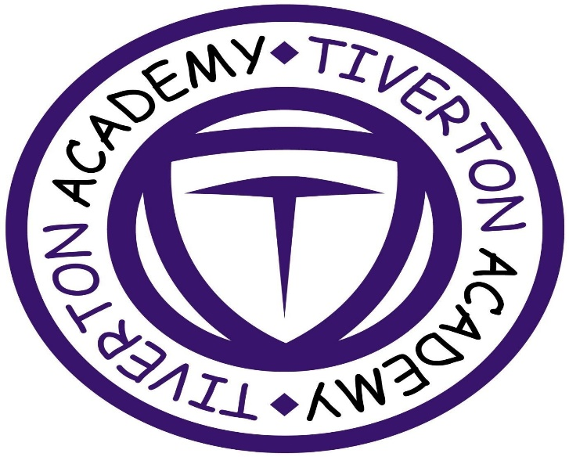
Valid From Date | Next Review Date
September 2020 | September 2021

Introduction
The internet provides a range of social media tools that allow users to interact with one another, for example from rediscovering friends on social networking sites such as Facebook to keeping up with other people’s lives on Twitter and maintaining pages on internet encyclopaedias such as Wikipedia.
While recognising the benefits of these media as opportunities for communication, this policy sets out the principles that Tiverton Academy staff are expected to follow when using social media.
It is crucial that young people, parents and the public at large have confidence in Tiverton Academy’s decisions and services. The principles set out in this policy are designed to ensure that staff members use social media responsibly so that confidentiality of young people, staff and the reputation of Tiverton Academy are safeguarded.
Policy Principles
Staff members need to be professional, responsible and respectful when using social media.
Staff must be conscious at all times of the need to keep their personal and professional lives separate. They should not put themselves in a position where there is a conflict between their work at Tiverton Academy and personal interests.
Staff must not engage in activities involving social media which might bring Tiverton Academy into disrepute.
Staff must not represent their personal views on those of Tiverton Academy on any social medium.
Staff must not discuss personal information about young people and other professionals they interact with as part of their job on social media. they must also not make reference to their day to day work at Tiverton Academy or give any details about their roles which identify Tiverton Academy as their place of work as this is a breach of confidentiality.
Staff must not use social media and the internet in any way to attack, insult, abuse or defame young people, their family members, colleagues, other professionals, other organisations or Tiverton Academy.
Staff must not use social media to express their discontent about their own role or any aspect about how Tiverton Academy operates. If there are any issues for staff in these areas they must use the appropriate channels to raise them with their line manager.
Staff must be accurate, fair and transparent when creating or altering online sources of information on behalf of Tiverton Academy.

Legal Framework
Tiverton Academy is committed to ensuring that all staff members provide confidential services that meet the highest standards.
All individuals working on behalf of Tiverton Academy are bound by a legal duty of confidence and other laws to protect the confidential information they have access to during the course of their work. Disclosure of confidential information on social media is a breach of a number of laws and professional codes of conduct, including:
- The Human Rights Act 1998
- Common Law Duty of Confidentiality
- The Data Protection Act 1998
Confidential information includes, but is not limited to:
- Person-identifiable information, e.g. young people and employee records protected by the Data Protection Act 1998
- Information divulged in the expectation of confidentiality
- Tiverton Academy business or corporate records containing organisationally or publicly sensitive information
- Any commercially sensitive information such as information relating to commercial proposals or current negotiations, and politically sensitive information.

Staff members should also be aware that other laws relating to libel, defamation, harassment and copyright may apply to information posted on social media, including:
- Libel Act 1843
- Defamation Acts 1952 and 1996
- Protection from Harassment Act 1997
- Criminal Justice and Public Order Act 1994
- Malicious Communications Act 1998
- Communications Act 2003
- Copyright, Designs and Patents Act 1988
Tiverton Academy could be held vicariously responsible for acts of their employees in the course of their employment. For example, staff members who harass co-workers online or who engage in cyberbullying or discrimination on the grounds of race, sex, disability etc. or who defame a third party while at work may render Tiverton Academy liable to the injured party.

Personal Accounts
We ask all staff members to remember that we work in an educational environment with young children. Be careful what you write online – as soon as you post something on the internet, it is out there forever, and you cannot delete it.
Staff members must not identify themselves as employees at Tiverton Academy in their personal web space. This is to prevent information on these sites from being linked with the home and school and to safeguard the privacy of staff members, particularly those involved in providing frontline services.
Staff members must not have contact through any personal social medium with any young person.
Staff members must not have any contact with young person’s family members through personal social media as that contact are likely to constitute a conflict of interest and may breach professional boundaries and relationships.
Staff members must decline “friend request” from young people they receive in their personal social media accounts.
On leaving Tiverton Academy’s service, staff members must not contact young people by means of personal social media sites and will be reported to the administrators of these sites if contact is made.
Information that staff members have access to in part of their employment, including personal information about young people and their family members, colleagues and Tiverton Academy corporate information must not be discussed on their personal web space.
Photographs, videos or any other types of image of young people and their families or images depicting staff members identifying the Tiverton Academy premises must not be published on personal web space.
Tiverton Academy staff email addresses and other official contact details must not be used for setting up personal social media accounts or to communicate through such media.
Staff members must not edit open access online encyclopaedias such as Wikipedia in a personal capacity at work. This is because the source of the correction will be recorded as the employer’s IP address and the intervention will, therefore, appear as if it comes from the employer itself.
Tiverton Academy’s corporate image must not be used or published on personal web space.
Tiverton Academy does not permit personal use of social media while at work. Access to social media sites for personal reasons is not encouraged and staff are expected to access these sites within their own time. Staff members are expected to devote their contracted hours of work to their professional duties and, in practice, personal use of the internet should not be on Tiverton Academy’s time.
Caution is advised when inviting work colleagues to be ‘friends’ in personal social networking sites. Social networking sites blur the line between work and personal lives and it may be difficult to maintain professional relationships or it might be just too embarrassing if too much personal information is known in the workplace.
Staff members are strongly advised to ensure that they set the privacy levels of their personal sites as strictly as they can and to opt out of public listing on social networking sites to protect their own privacy. Staff members should keep their passwords confidential, change them often and be careful about what is posted online; it is not safe to reveal home addresses, telephone numbers and other personal information. It is a good idea to use a separate email address just for social networking so that any other contact details are not given away.
We ask that you do not post, share or forward anything unsuitable or inappropriate. If you are unsure on whether content is suitable or not, please seek advice from your computing coordinator or the appropriate line manager, who will be able to advise further on this matter.
Tiverton Academy reserves the right to decide on what is considered appropriate and what is not. If inappropriate content is noted, Tiverton Academy will take action, and, where appropriate, will contact the colleague in question to ensure the content is immediately deleted.
Do note upload content that is deemed inappropriate for public display or content which either reflects badly on yourself, or where it could be deemed to bring Tiverton Academy into disrepute.
Any inappropriate behaviour* is to be reported to the Academy with evidence (generally a screenshot) of the offending content. The Academy will take appropriate action in response to this, and, if in breach of Tiverton Academy policy, inform the appropriate line management.
*Inappropriate behaviour can include, but is not limited to:
- Discrimination – comments/content that could be deemed as racist, sexist, ageist, class, ethnicity, national origin, religion, sexual preference, disability or any other classification.
- Violent behaviour – This can include such things as threats, abusive/offensive language.
- Bullying and harassment – this includes teasing, name calling, targeting specific users, etc.
- Explicit content – can be any type of media including photos, videos, text or audio.
- Trolling – intentionally provoking a negative response from someone.
- Negative content – any content that could potentially reflect badly on the Academy.

Breaches of the policy
Any breach of this policy may lead to disciplinary action being taken against the staff member/s involved in line with Tiverton Academy’s Disciplinary Policy and Procedure.
A breach of this policy leading to breaches of confidentiality, or defamation or damage to the reputation of Tiverton Academy liable to third parties may result in disciplinary action or dismissal.
Contracted providers of Tiverton Academy services must inform the relevant Tiverton Academy manager immediately of any breaches of this policy so that appropriate action can be taken to protect confidential information and limit the damage to the reputation of Tiverton Academy. Any action against breaches should be according to contractors’ internal disciplinary procedures.
Under no circumstances should any member of staff bring Tiverton Academy into disrepute using social media. This includes endorsing any online extremist groups or organisations who do not comply with the Academy’s British Values.

