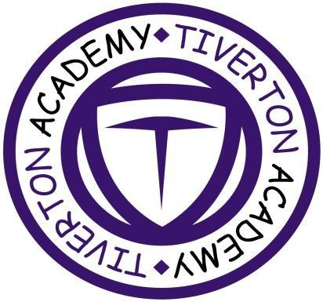

This term in Year 5, we are studying: Moving People. The teaching of this topic will be embedded in core and non-core lessons through our IPC unit.

**Year 5: Spring Term**

**Moving People**

**Literacy**

In Literacy this term we are reading the dystopian fiction, “After tomorrow” by Gillian Cross. We will be using this fascinating and thought-provoking vision of an imagined future, where Britain is no longer a safe place to be, to explore the issue of refugees from a different perspective. We will also be delving more deeply into the current crisis facing Syrian people through the novel “Welcome to Nowhere” by Elizabeth Laird.

**Maths**

In Maths this term, we are focusing on multiplication and division of 4-digit numbers we will also be looking at fractions. We will be continuing our focus on these and also have challenges alongside with fluency and problem-solving skills.

We will be exploring how to apply our knowledge and skills to real life situations, as well as mastering the methods for using multiplication, division and fractions.



**Creative Arts**

In visual art, we will be learning about what child refugees have gone through. We will be looking at before and after pictures of the countries they have left and we will be sketching images to show the devastation. We will study pictures and think about what colours to use and how colour affects the emotions.

In Music, we’ll be finding out: how to compose Impressionist music; how to record and perform our work and how music reflects a place and time.

In Dance, we’ll be finding out: how to use gestures and movement and how to create a performance art piece.

**Computing**

We will be continuing our ongoing learning about online safety and responsible use of the internet, but we will be also be delving into the way in which we can be more critical of what we see and read online. We will be working on our coding skills to create our own apps using random numbers to keep score. We will also be learning about spreadsheets and their applications.

**PSHE: No Outsiders in Our School**

This term, we will continue to learn about the 2010 Equalities Act and the protected characteristics that make up this important law. We will continue to work to make sure that everyone is included.

Our **SRE** lessons will focus on puberty.

Our value is: forgiveness

**Science**

In Science, we are going to be learning about The Life Cycle. We will be looking at the life cycle of plants and how it compares to mammals and insects. We will be able to describe the life processes of reproduction in some plants. We will be able to take measurements and present findings. We will be able to understand the importance of reproduction in plants.