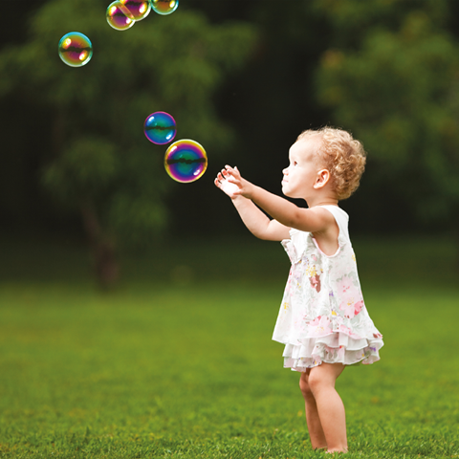

**Year 1: Spring 1 2022**

**Sensational**

During this half term Year 1 will be introduced to the ‘Sensational’ topic. The topic will allow us to investigate animals including humans, our senses and materials. It’s an interesting blend of science, art, music and design technology.

**Maths**

How to use greater than, less than & equal to

and using place value.

**Music**

Percussion instruments and songs

**PE/Dance**

Using hockey equipment and dancing.

**English**

We will be studying the story ‘Chopsticks’ by Jon Berkeley, finding out about instructions and developing our own ideas for stories using Bedtime For Monsters by Ed Vere.

**Science**

Animals Including Humans and our senses.

Art

Patterns and making a free standing structure.

**School value**

Forgiveness

**Computing**

We shall be learning how to use Scratch.