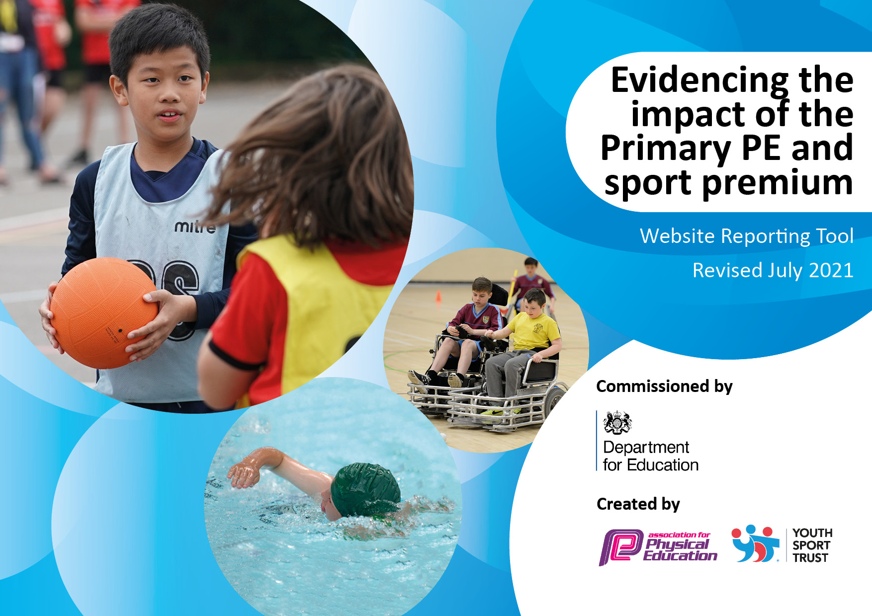

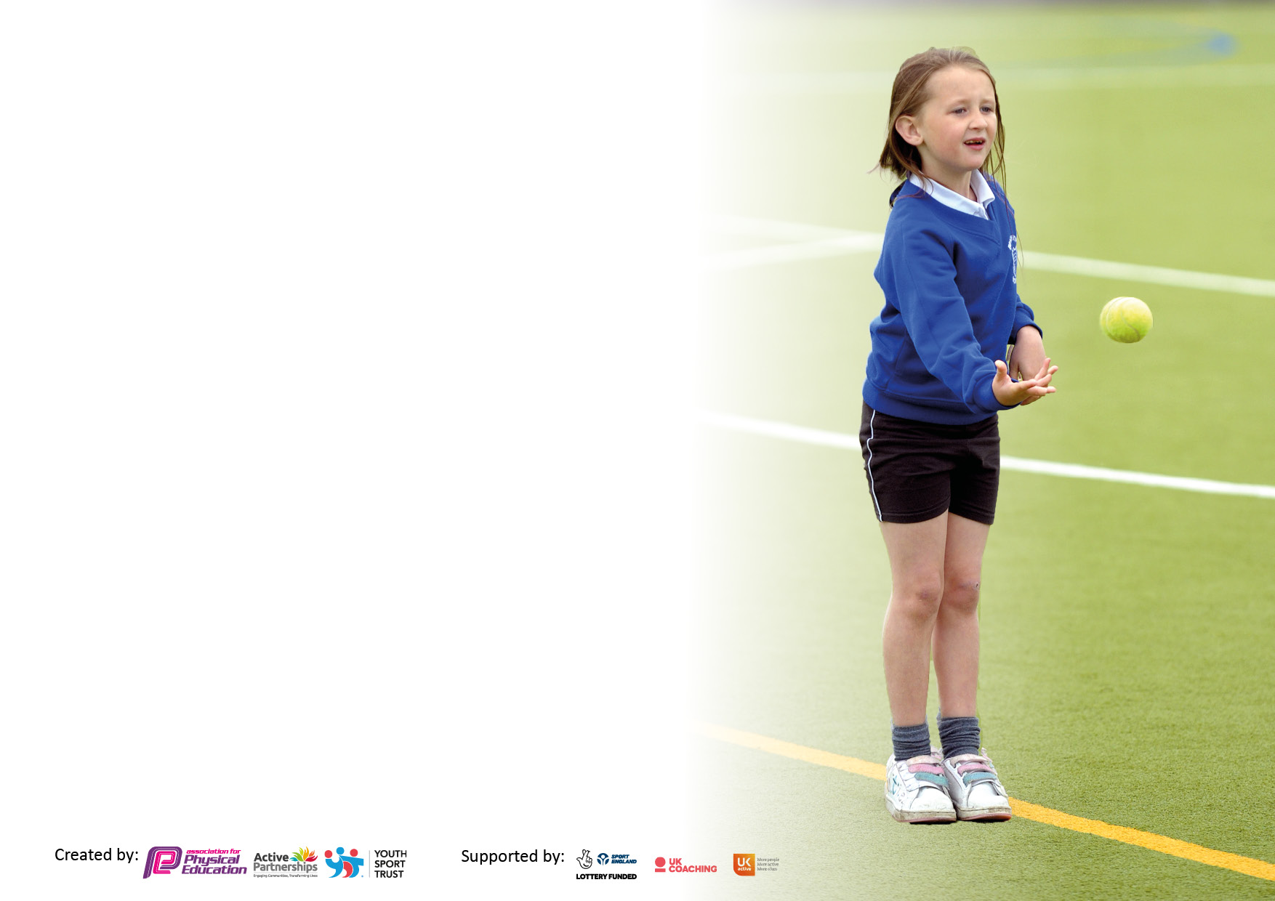

It is important that your grant is used effectively and based on school need. The Education Inspection Framework makes clear there will be a focus on **‘whether leaders and those responsible for governors all understand their respective roles and perform these in a way that enhances the effectiveness of the school’**.

Under the Quality of Education Ofsted inspectors consider:

**Intent** - Curriculum design, coverage and appropriateness

**Implementation** - Curriculum delivery, Teaching (pedagogy) and Assessment

**Impact** - Attainment and progress

To assist schools with common transferable language this template has been developed to utilise the same three headings which should make your plans easily transferable between working documents.

Schools must use the funding to make **additional and sustainable** improvements to the quality of Physical Education, School Sport and Physical Activity (PESSPA) they offer. This means that you should use the Primary PE and sport premium to:

* Develop or add to the PESSPA activities that your school already offer
* Build capacity and capability within the school to ensure that improvements made now will benefit pupils joining the school in future years
* The Primary PE and sport premium should not be used to fund capital spend projects; the school’s budget should fund these.

Pleasevisitgov.ukfortherevisedDfEguidanceincludingthe5keyindicatorsacrosswhichschoolsshoulddemonstrate animprovement.Thisdocumentwillhelpyoutoreviewyourprovisionandtoreportyourspend.DfEencouragesschools to use this template as an effective way of meeting the reporting requirements of the Primary PE and sport premium.

We recommend you start by reflecting on the impact of current provision and reviewing the previous spend.

Schools are required to publish details of how they spend this funding, including any under-spend from 2019/2020, as well as on the impact it has on pupils’ PE and sport participation and attainment. **All funding must be spent by 31st July 2022.**

We recommend regularly updating the table and publishing it on your website throughout the year. This evidences your ongoing self-evaluation of how you are using the funding to secure maximum, sustainable impact. Final copy must be posted on your website by the end of the academic year and no later than the 31st July 2021. To see an example of how to complete the table please click HERE.

Created by: Supported by:

**Details with regard to funding**

Please complete the table below.

|  |  |
| --- | --- |
| Total amount carried over from 2019/20 | £ 0 |
| Total amount allocated for 2020/21 | £ |
| How much (if any) do you intend to carry over from this total fund into 2021/22? | £0 |
| Total amount allocated for 2021/22 | £18, 156 |
| Total amount of funding for 2021/22. To be spent and reported on by 31st July 2022. | £18,156 |

**Swimming Data**

Please report on your Swimming Data below.

|  |  |
| --- | --- |
| Meeting national curriculum requirements for swimming and water safety.  N.B. Complete this section to your best ability. For example you might have practised safe self-rescue techniques on dry land which you can then transfer to the pool when school swimming restarts.  **Due to exceptional circumstances priority should be given to ensuring that pupils can perform safe self rescue even if they do not fully meet the first two requirements of the NC programme of study** | Children swim for a 2 week block every afternoon. The year 6 children have lessons on safe self-rescue in the pool as part of their 2 week block. |
| What percentage of your current Year 6 cohort swim competently, confidently and proficiently over a distance of at least 25 metres?  **N.B.** Even though your pupils may swim in another year please report on their attainment on leaving primary school at the end of the summer term 2021.  Please see note above | 77% |
| What percentage of your current Year 6 cohort use a range of strokes effectively [for example, front crawl, backstroke and breaststroke]?  Please see note above | 77% |
| **What percentage of your current Year 6 cohort perform safe self-rescue in different water-based situations?** | 67% |
| Schools can choose to use the Primary PE and sport premium to provide additional provision for swimming but this must be for activity **over and above** the national curriculum requirements. Have you used it in this way? | Yes |

**Action Plan and Budget Tracking**

Capture your intended annual spend against the 5 key indicators. Clarify the success criteria and evidence of impact that you intend to measure to evaluate for pupils today and for the future.

|  |  |  |  |  |
| --- | --- | --- | --- | --- |
| **Academic Year:** 2020/21 | **Total fund allocated:** | **Date Updated:** | |  |
| **Key indicator 1:** The engagement of all pupils in regular physical activity – Chief Medical Officers guidelines recommend that primary school pupils undertake at least 30 minutes of physical activity a day in school | | | | Percentage of total allocation: |
| 70% |
| **Intent** | **Implementation** | | **Impact** |  |
| Your school focus should be clear what you want the pupils to know and be able to do and about  what they need to learn and to  consolidate through practice: | Make sure your actions to achieve are linked to your intentions: | Funding allocated: | Evidence of impact: what do pupils now know and what can they now do? What has changed?: | Sustainability and suggested next steps: |
| All children will take part in Physical  education in school which will be led  by two sports coaches  Increased PE equipment during break  and Lunchtime so that pupils can  choose to play with PE equipment  Children in Year 2 to Year 6 will all have a block of swimming lessons at Birmingham University  Key stage 1 children will have weekly forest school sessions throughout Autumn and Spring term . Key stage 2 will have weekly forest school sessions throughout Summer term. | All children have 3 hours of PE every week. This consists of two games lessons and one dance lesson  Sports coaches will identify and purchase a range of PE equipment that can be used at play and lunch by all children. During lunch duty sports coaches will support and direct the children in using the new equipment.  Children in year groups 2 – 6 will all have 2 weeks of intense extra swimming lessons. They will swim for 1 hour a day for 10 days to improve their ability and confidence. They will be taught by qualified swimming coaches.  Children in all year groups will have  forest school provision as part of  their physical activity on a termly basis. | £ 0  £100  £4800  £10,150 | Pupils are exposed to a wide range of sporting activities. Their overall fitness levels have increased and they have developed a wide range of skills and knowledge across a range of sports. All children have developed a love for and a wide range of dances. This has increased their confidence and has also enabled G&T children to form a dance squad that performs across the country.  All children will have the opportunity to take part in sporting activities during break and lunch increasing their levels of activity.  In all year groups, the percentage of children who are able to swim competently over short distances up to 25m + has increased.  The % of Y6 children who can swim 25m has also increased from the previous year.  Develops confidence and  self-esteem through learner  inspired, hands-on experiences in a natural setting. children will  use and develop their play,  exploration and risk-taking skills | We will continue to provide every child with 3 hours of PE each week.  We will, further develop our links with KES to offer children more specialist sports opportunities.  PE coaches will now look at identifying play leaders who are able to lead on a range of lunch time activities.  Sourcing of local opportunities and links with Birmingham Uni to ensure any non-swimmers are receiving additional swimming lessons throughout the year.  Arrange physical activity challenge days with Hampstead Hall. |
| **Key indicator 2:** The profile of PESSPA being raised across the school as a tool for whole school improvement | | | | Percentage of total allocation: |
| 0% |
| **Intent** | **Implementation** | | **Impact** |  |
| Your school focus should be clear what you want the pupils to know and be able to do and about  what they need to learn and to  consolidate through practice: | Make sure your actions to achieve are linked to your intentions: | Funding allocated: | Evidence of impact: what do pupils now know and what can they now do? What has changed?: | Sustainability and suggested next steps: |
| Celebration assemblies after each match played/competition attended. Children are awarded certificates.  Events are celebrated on social media.  To advertise sporting achievements on the school blogs on the website. | Achievements in assembly are  celebrated (any match results and  notable achievements in lessons).  Achievements are shared and celebrated. Parents can see evidence of the range of achievements. | £0  £0 | Pupils recognise milestones in PE and know their achievements are celebrated.  Other children are encouraged to be part of a sporting team.  Achievements are shared and celebrated. The range of sporting opportunities available are advertised to perspective and current parents. | During fortnightly Congratulations assemblies, the PE coaches will identify 1 child in each class to receive an award for PE.  Continue to keep the blogs up to date. |

|  |  |  |  |  |
| --- | --- | --- | --- | --- |
| **Key indicator 3:** Increased confidence, knowledge and skills of all staff in teaching PE and sport | | | | Percentage of total allocation: |
| 21% |
| **Intent** | **Implementation** | | **Impact** |  |
| Your school focus should be clear | Make sure your actions to | Funding | Evidence of impact: what do | Sustainability and suggested |
| what you want the pupils to know | achieve are linked to your | allocated: | pupils now know and what | next steps: |
| and be able to do and about | intentions: |  | can they now do? What has |  |
| what they need to learn and to |  |  | changed? |  |
| consolidate through practice: |  |  |  |  |
| For all staff to be confident and competent in teaching PE lessons through carefully planned CPD  Staff INSET sessions will increase teacher’s expertise and confidence in teaching a range of sports. | School employs 2 sports coaches full time. The teachers and TA’s work alongside the sports coaches to plan for, teach and assess children’s outcomes during PE lessons.  All teachers attend 2 PE lessons a week and TA’s attend 1. This provides the teachers with CPD in teaching games and dance.  Once every half term , the PE coaches will deliver a training session for teachers and TA’s | £ 5,000  £0 | The quality of the teaching of PE has improved throughout the school.  Staff confidence in teaching dance and games has improved.  Planning for PE and the progression of skills is robust.  Teachers are able to accurately assess children’s ability in PE  Increased levels of skills and knowledge in teaching a wide range of sports for teachers and TA’s. Evidence that this has helped in implementing | Dance squad identifies G&T children. This will be extended to other groups who show a particularly high level of skill in particular sports.  Expand to a wider range of sporting activities. |
| **Key indicator 4:** Broader experience of a range of sports and activities offered to all pupils | | | | Percentage of total allocation: |
| 9% |
| **Intent** | **Implementation** | | **Impact** |  |
| Your school focus should be clear | Make sure your actions to | Funding | Evidence of impact: what do | Sustainability and suggested |
| what you want the pupils to know | achieve are linked to your | allocated: | pupils now know and what | next steps: |
| and be able to do and about | intentions: |  | can they now do? What has |  |
| what they need to learn and to |  |  | changed? |  |
| consolidate through practice: |  |  |  |  |
| Additional achievements:  To identify children who display particular talents in ballet  To expose children to professional coaching in squash working alongside Birmingham University and Rackets Cubed.  Through partnerships with KES children will be offered a wide range of sporting opportunities that are available for secondary school children. Use of specialist facilities.  Through Tennis coaching pupils will develop their skills and discover their talents in tennis.  Through Rugby coaching pupils will develop their skills and discover their talents in Rugby.  Working alongside Warwickshire Cricket club, pupils will receive coaching from professionals to improve their skills and understanding of playing cricket.  Working alongside Harborne Golf club pupils will receive coaching from professionals to improve their skills and understanding of playing golf. | Working alongside the Royal Ballet Dance track programme with y1 children to offer free scholarships in dance lessons for G&T Year 1 children.  Year 4 children will go to Birmingham University for 2 hours every week. They will have 45 minutes squash coaching, 45 minutes Maths tuition and 30 mins for a hot meal.  Children take part in a wide range of opportunities that would normally not be available to them. They are taught by qualified coaches and their teachers in a professional sporting environment.  Whole school experience a range of tennis coaching techniques and build an understanding of the rules of the sport and develop confidence in tennis.  Whole school experience a range of rugby coaching techniques and build an understanding of the rules of the sport and develop confidence in it.  Whole school experience a range of cricket coaching techniques and build an understanding of the rules of the sport and develop confidence in it.  Whole school experience a range of golf coaching techniques and build an understanding of the rules of the sport and develop confidence in it. | £ 400  £1155  £0  £0  £0  £0  £0 | 8 Year 1 children offered free scholarship opportunity for Royal Ballet dance lessons.  Squash coaches have identified children who are G&T at squash. Children have been immersed in the University campus. Y4 has a high % of PP children who are experiencing an elite sport.  Children discover new sports and new talents. Opportunities to pursue these sports and children are offered Summer school places at KES  Children have the opportunity to discover their talents in tennis and 77% of the children have experienced tennis for the first time.  Children have the opportunity to discover their talents in rugby and 67% of the children have experienced rugby for the first time.  Children have the opportunity to discover their talents in cricket and and play cricket at Edgbaston Cricket club.  Children have the opportunity to discover their talents in golf and 100 % of the children have experienced golf for the first time. | This will e a yearly commitment. Encouraging reluctant families to ensure they take their children to the free sessions.  The programme will continue annually. Identify further groups of children to participate.  Continue to expand and develop this partnership.  This will be an annual coaching intervention. Look for children who would benefit from joining a tennis club.  Signposting children to local rugby clubs. Rugby now integrated into the PE scheme of work.  47% of children now play cricket outside of school at Edgbaston Cricket ground.  Apply to be part of the programme for the next academic year. |

|  |  |  |  |  |
| --- | --- | --- | --- | --- |
| **Key indicator 5:** Increased participation in competitive sport | | | | Percentage of total allocation: |
| 0 % |
| **Intent** | **Implementation** | | **Impact** |  |
| Your school focus should be clear | Make sure your actions to | Funding | Evidence of impact: what do | Sustainability and suggested |
| what you want the pupils to know | achieve are linked to your | allocated: | pupils now know and what | next steps: |
| and be able to do and about | intentions: |  | can they now do? What has |  |
| what they need to learn and to |  |  | changed?: |  |
| consolidate through practice: |  |  |  |  |
| To be part of the Birmingham School games competition for dodge ball, football, multi skills, hockey and dance.  To participate in competitive tournaments with all other schools in the school games group.    To compete in the Great Big Dance Off Competition  To be part of the Redditch got to dance competition.  To compete as part of Kings Norton football partnership in inter school competitions.  To compete as part of  Birmingham Netball league against other primary schools from Birmingham. | Different groups of children are chosen to represent the school in competitive games against other Birmingham schools.  The Dance squad practise and perform their dance at a regional and National levels. The children perform at theatres and gain a sense of audience.  The Dance squad practise and perform the Redditch Got to dance competition. The children perform at theatres and gain a sense of audience.  The football team will participate in the inter league football matches against 12 other primary schools. They will learn how to compete and play fairly by the rules  The netball team will participate in the inter league netball matches against 10 other primary schools. They will learn how to compete and play fairly by the rules | £0  £0  £0  £0  £0 | Achieved Gold standard in the Birmingham School games  Gold achieved in both the Regional and National competitions.  Achieved first place in the competition.  Children gain a sense of being part of a team. They learn to win and loose and to congratulate others on their achievements. They also get to work alongside other children from other schools.  Children gain a sense of being part of a team. They learn to win and loose and to congratulate others on their achievements. They also get to work alongside other children from other schools. | Continue next academic year.  Continue next academic year.  Enter again next academic year.  Sports coaches will continue to be part of this and will ensure the children are able to participate each year.  Sports coaches will continue to be part of this and will ensure the children are able to participate each year. |

|  |  |
| --- | --- |
| Signed off by | |
| Head Teacher: | Debbie Norbury |
| Date: | 24/11/22 |
| Subject Leader: | Alice Hale and Rebecca Meah |
| Date: | 24/11/22 |
| Governor: | N/A |
| Date: | N/A |